Solution description document **- Assignment 1.2**

**1. Conceptual architecture of the distributed system**

The solution is implemented in only one module, server application.

|  |  |
| --- | --- |
|  | **Servlets** - represents controllers from MVC pattern  **Views** - static pages html and JSP , represents the views from MVC pattern  **Entities** - contains models of our application  **Business logic** - contains the logic of our application  **DAO** - layer to communicate with MySQL database |

Server Application

**2. Database diagram**

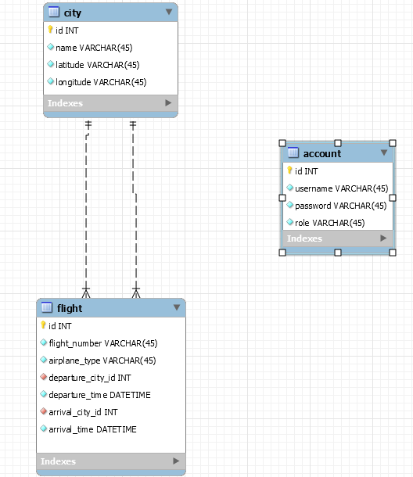

**3. Deployment diagram**

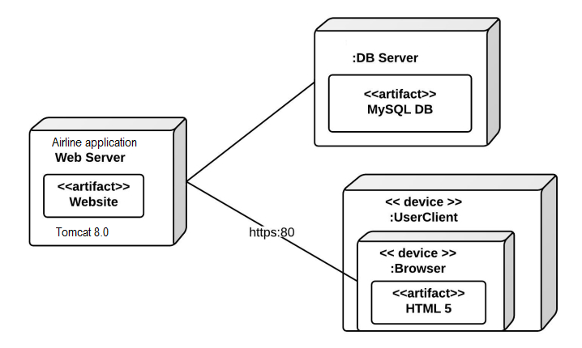

**4. Readme**

Assignment 1.2

This is sample java web application that exercises the Request-Reply Communication Paradigm.

In order to build and deploy the application on your local machine you need to have the following:

- Apache Tomcat 8.0.

- MySQL Server

- Maven build automation tool

I you have done the previous steps you should:

- start MySql server and run the script (located in /resources/mysql-database folder) to create a the database used by this application

- run "mvn clean install" (Maven commands) in a terminal opened in the project's folder; the result will be a target folder wich contains .war application.

- copy the .war file from target folder to webapp (webapp folder is located on your Apache Tomcat installation directory);

- run tomcat server

- open chrome browser and write "www.localhost:8080/'name of .war file" and navigate in the application using credentials (username:admin, password:admin)